Civics/Econ
World Poverty Assignment

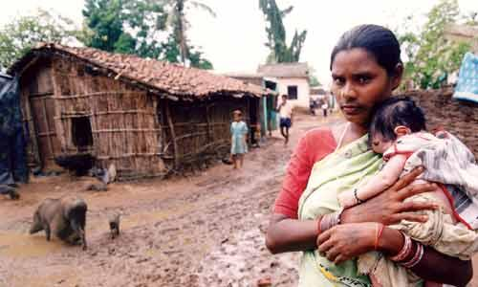

This assignment will focus on the poorest countries in the world, and some of the reasons that make them poor. Your group will pick a country to focus on from the UN’s list of the fifty poorest countries in the world (see handout). Using the internet or other resources in the library, try to assess the economic situation in that country, and use PowerPoint to assemble a collection of ten photos that illustrate poverty levels in the country.
How do people live there?
Where does the money they have come from?
What problems do they face? And how do these problems affect their daily lives? (perspective)
What has caused some of their problems? (War, poor government, lack of education?). Are these conditions in or out of their control; or both? (perspective)
For Example:
If the country does not provide education to girls, then half the country has no ability to better themselves or their country.

Your task is to both look at these issues above from a Western perspective and the perspective of the people living in that specific country.

This project is a summative grade, and will be done in pairs.
- We will be in the computer lab for one or two days to research and assemble the projects.
- Your group will present your project to the class. Both members of the group need to help talk and present.
- Your slides only need simple captions (if any at all)—don’t fill them with text and then read to the class.
- The presentations need to be 3 to 7 minutes. Try to get your impact from your photos. You may use a notecard or notes when you present, but again—try not to read to the class, your presentation will be less interesting that way. Try to know enough about your country that you can talk about it for a few minutes without notes, and try to use your own words as you talk.- Your presentation should include 10 slides (or 10 Prezi topic transitions)

Honors— Honors students need to pair with other honors students for this project. The assignment is the same, but you should aim for a bit more analysis of the root causes of poverty in the nation you focus on.

World Poverty Project Persuasive Writing Prompt

In a persuasive letter, you are to voice your concerns to an appropriate person and/or group (government official, activist group, charity, embassy, United Nations, etc.) regarding the issues of poverty and those effects on the country and its citizens.

In your persuasive letter, you need to explain who you are, why you are writing to the particular group and/or individual, the specific issue of poverty, and how you would like them to act on this issue. In order to be persuasive, you must use compelling language and provide evidence to support your claims.

