STEM Capstone Seminar Course Description
This semester course is a STEM research seminar that is required for STEM certification. We will first be looking into components of STEM and learning advanced research and analytical skills. Students will choose a STEM/global topic they are interested in and conduct research to learn more about the topic. Students are responsible for documenting their research, thinking on a blog, developing a website, creating a culminating product to reflect their learning, and acting on their findings. The product is determined by the student and based on their interests and topic. The students will present their finished product in multiple venues: to peers, a panel of adults, at the GIN conference and at the Global Studies/STEM Fair.
Ann Marie Mahar
amahar@rutlandhs.k12.vt.us
770-1108; Lab 8
http://rutlandhighschoolcapstone.weebly.com/

Required Materials:
- A three ring binder with some lined paper, either in a notebook or loose leaf
- A writing implement (pen/pencil/marker)
- Ear buds for in class use
- Access to the internet - at school, on your phone, or at home (classroom computers will be used)
If you have trouble getting any of these, please speak with me as soon as possible.
- Research blog & website-utilizing the capstone website:
http://rutlandhighschoolcapstone.weebly.com/

Assessments & Assignments
- Blog: You are expected to write on your blog at least 2 times each week and to comment on at least 1 of your classmates’ blog posts.
  - Blogging might be related to topic development, research, reflections, or teacher prompts.
  - Your responses should be thoughtful and complete. These are public documents, so your writing should be appropriate and formal.
  - Each week you will receive feedback on your posts
- Website: Create a Weebly website from a given template
- Original Product: paper, science research project, engineering project, digital infographic, film, TED talk, public service announcement, etc.
- Final presentation (see below)
- Assignments, check-ins, peer feedback, self-assessment
- You are responsible for working productively in class and for completing all assignments on time.

Capstone Final Presentation
This product should
- utilize technology (supporting your oral presentation), for example Power Point or Prezi
- be 20 minutes in length with 5 additional minutes for audience questions and 2 minutes for your closing remarks
- explain why it matters to you and more importantly why it should matter to others
  - make the global issues connection
  - make local connections
  - draw people in by educating them and exciting them
- summarize your research
- summarize your findings/results
- reference your product (paper, science research project, engineering project, digital infographic, film, TED talk, public service announcement)
- contain an action plan
- be clear and understandable to anyone

Vermont State Science, Engineering, Math, STEM fair at Norwich University- optional!!
    - Some students may choose to present their project here if it followed the scientific method or engineering method. This opportunity is predetermined by the teacher and student in order to complete preliminary paperwork. Additional STEM hours are available for presenting at this event. Also, students have the potential to win awards, scholarship money, and cash!
    - Date: March 28, 2015
    - Website: http://vssmf.pbworks.com/w/page/5426544/FrontPage
    - Project requirements: project using the scientific method or engineering design model
      - that creates original data (without human or animal sources)….see website for
      - further clarification
    - Paperwork: ISEF paperwork begins at the start of your project (awards & scholarship availability)

Grading and Assessment
- All of your work will be graded according to standards. You will receive the scales that indicate four levels of proficiency early in the semester. They are also available on the website.
- All preliminary work will count for 50% of your grade. The final product presentation will count for 50% of your grade. You are required to present your final product at the following public venues: in class, small school group, GIN Conference and the STEM Fair. Failure to do this will retroactively diminish your grade.
- Standards referenced grading conversion chart: 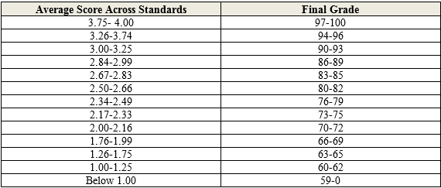

Course Learning Goals: You must show mastery of the following standards in order to be successful in this course. A proficiency scale exists for clarification of each goal. These can be found on the website.
STEM
- Science - explain science within individual project depth, conduct experiment using the scientific method, analyze and interpret data
- Technology- use technology such as blogging, citation tools, Google document, forms, sheets, and presentation, infographic tools, website development
- Engineering- question development, problem solving, engineering method
- Mathematics- statistical analysis of data, presentation of data in visual schematics
Capstone
- Conduct Research-use of sources
- Conduct Research- citation
- Literacy
- Form opinions based on exploration and evidence
- Write, speak, and design in a way that is clear and persuasive
- Communication- Present information orally in a way that is clear and persuasive
- Take Action: View yourself as able to help solve global challenges
Work Habits
- Engagement
- Respect
- Timeliness/preparedness

