Blog Entry
CAP 9: The student will be engaged while in the classroom.
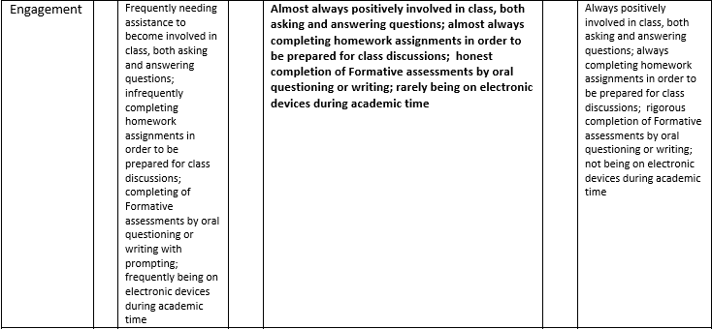
CAP 1: The student will be able to form opinions based on exploration and evidence.
